**MID TERM ONE ASSESSMENTS 2024**

**LEARNING AREA: ENGLISH LANGUAGE**

**CLASS : PRIMARY ONE**

**PUPIL’S NAME :**

**Each correct answer carries two marks.**

**1.** Complete the sentences.

My name is ________________________________.

I am _______________ years old.

**2.** Match words to plurals.

boy benches

dog boys

box dogs

bench boxes

**3.** Write in small letters.

T __________

F __________

Y __________

M _________

N __________

G ___________

**4.** Fill in the missing letters.

b ___ o k b ___ l l

p ___ n c u ___

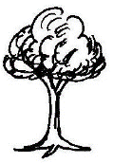**5.** Complete the sentences correctly.

That is a _____________

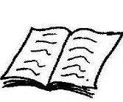

This is a ______________

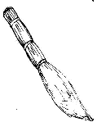

That is a _____________

(book, tree, broom)

**6.** Circle the odd man out.

a) girl boy dog

b) cow goat lion

c) broom dustbin tree

d) dress shirt table

**7.** Write the now tense.

go going

sweep ________________

jump ________________

stand ________________

cook ________________

**8.** Read and shade.

red yellow

green blue

**9**. **Match correctly.**

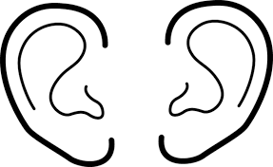 eyes

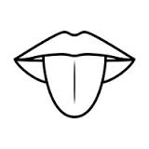

nose

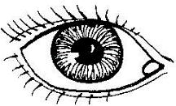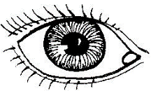 head

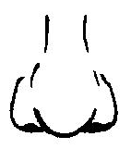

ears

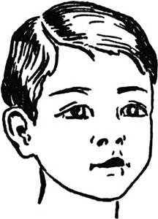

tongue

**10.** Write **an** or **a** to fill the gaps.

This is _______ desk.

I can see __________ axe.

It is _______ box.

I have _______ apple.

**11.** Name the things found at home.

|  |  |
| --- | --- |
|  |  |
|  |  |

(jerrycan, cup)

**12.** **Read the poem and then answer the questions in full sentences.**

*At school At school*

*There are many things at school.*

*like chairs, pencils, dusters and others.*

*At school At school*

*We sit on the chairs*

*We write with pencils*

*And a duster to lean the chalkboard.*

**Questions.**

1. The poem is about _________________________________

2. Write four things found at school.

i) ____________________________

ii) ____________________________

iii) ____________________________

iv) ____________________________

3. where do we sit?

We sit on the _________________________

4. We use a pencil to __________________. (write, dance)

5. A duster is used to ___________________ chalkboard.

(wash, clean)